**PROGRAMMING LANGUAGES WITH LAB**

Laboratory Activity 2

**Class and Object**

|  |
| --- |
|  |

Score

*Submitted by:*

**Maupoy, John Rex O.**

**<Schedule> / BSCS-2-YA-1**

*Date Submitted*

**10-12-2022**

*Submitted to:*

**Engr. Maria Rizette H. Sayo**

General Instruction:

1. Read the instructions first before solving the computing problems.
2. For the items with programming solutions, copy the link of your python program "Lab Activity 2" from your repository
3. Refer to the rubrics in grading each computing problem.

Problem 1. Examine the program below and create an appropriate flowchart (50 points)

(Note: You may use LucidChart or Word Processing tool)

n = 20

total_numbers = n

sum = 0

while n >= 0:

sum += n

n -= 1

print("sum =", sum)

average = sum / total_numbers

print("Average = ", average)

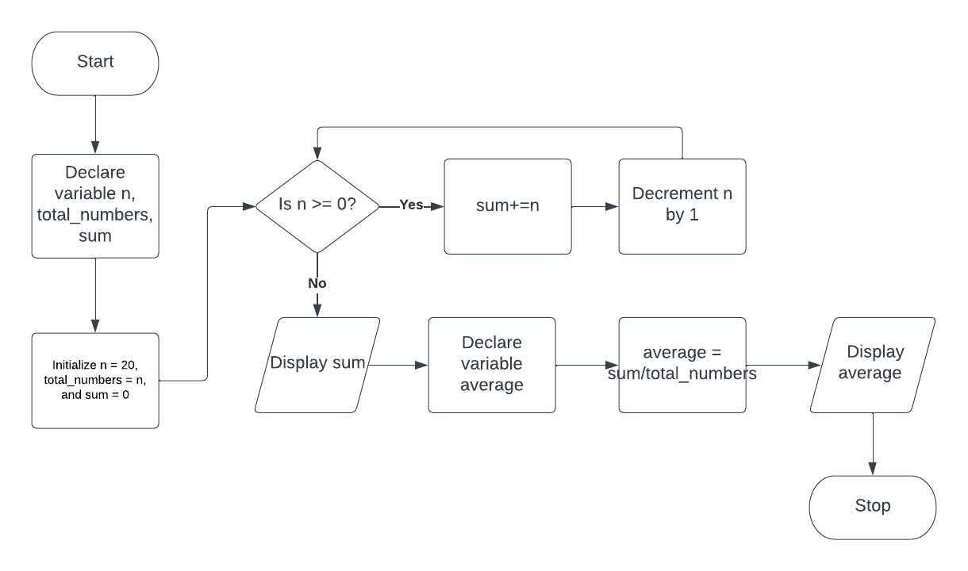

Problem 2. (50 points)

1. Write a Python to display your full name, student number, age, and course
2. Create a class named Student with attributes: Name, Student_No, Age, School, and Course
3. Create an object name Myself and assign an instance for each attribute.
4. Create a method Info() using an instantiation of a class.
5. Insert your GitHub link "Lab Activity 2" from your repository named "OOP 1-1"

